(Approx. 386 words)

Night Light: A Little-Used Feature of Windows 10
By Martin Arbagi, Editor, The DataBus, Dayton Microcomputer Association, OH
www.dma1.org
Martin.Arbagi (at) Gmail.com

An increasing amount of scientiﬁc evidence now indicates that bluish-white light—the kind that typically occurs at noon of a clear day—tends to stimulate the brain centers that keep us awake. On the other hand, light from the red-orange bands of the spectrum—the type that usually occurs at dawn or evening—either makes us sleepy or at least does not actively excite the “waking centers” of our brains.

Unfortunately, bluish-white light is precisely what the screens of most computer monitors and other digital devices usually emit. Thus, for example, reading yourself to sleep with an e-book can actually keep you awake, as can taking that spread sheet home from the oﬃce so you can work on it after dinner.

Microsoft’s latest operating system, Windows 10, has a feature that can mitigate this problem. It’s called “Night Light,” and is frequently ignored when setting up or customizing a PC. I myself initially thought it was designed to have monitors glow softly at night, thereby making the computer easier to ﬁnd in a darkened room. I ﬁnally blundered into the correct use of Night Light almost by accident. Night Light is easily set up. Merely go to your Desktop and right-click your mouse. (Left-click if you use a left-handed mouse, as I do.) The familiar screen shown in Figure 1 shows up. Now click on “Display Settings.” The screen shown in Figure 2 now appears. Finally, move the slide switch labeled “Night Light” (circled in red) to the on position.

Two comments before ﬁnishing:
(1) Night Light knows when to turn on. If you look closely at Figure 2, you’ll see that the day I wrote this article, my PC switched to Night Light at sunset: 8:58 p.m. Obviously, I was writing during the summer! Windows 10 knows your approximate location by, among other things, your IP address, and will adjust for time zone, latitude, longitude, and Daylight Savings Time.
(2) Turn Night Light off if you are working on something that requires true color rendition. For example, if that project you brought home from the oﬃce is not a spread sheet, but rather an advertising campaign with lots of graphics, you don’t want the color distortion that Night Light will inevitably generate.

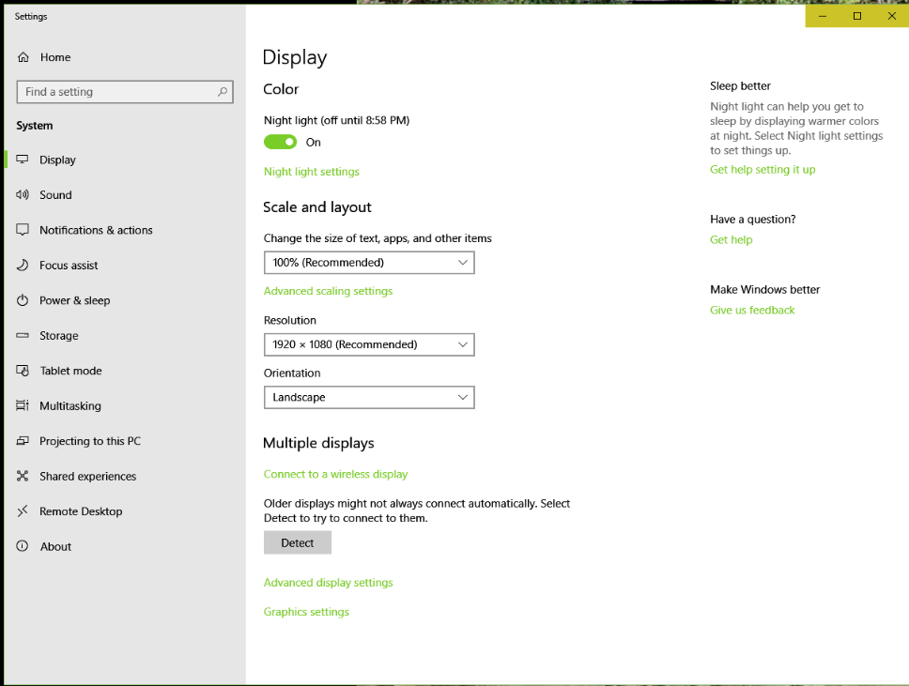
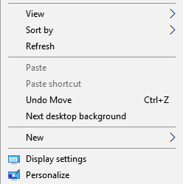
Figure 1
Figure 2

